# Technical design of plugin in dynamic rules for docs process

## Summary

This document cover the technical specification of plugin for dynamic rule used in DOCS process system. The plugin act as API service which would provide the calculated capability of dynamic rules. The automate flow invokes plugin function by calling unboud action and pass the dynamic rules for calculation, then plugin would consume the rules provided by automate flow and return calculated result.

## Design Architecture

The following diagram demonstrate the integration between plugin and automate flow.

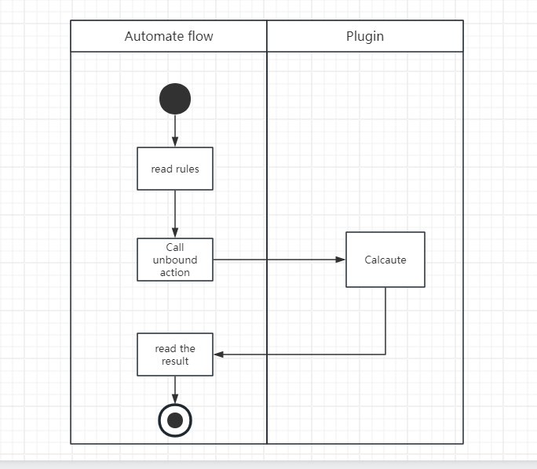

## Rule scheme design

This section specify the rule scheme used in plugin.

Rule includes basic data involved in calculation in plugin.

### Rule metadata

|  |  |  |
| --- | --- | --- |
| Name | Description | type |
| label | Name of the rule | string |
| operator | Integer value representing the operator you want to execute. See Operator. | string |
| value | The value you want to execute in calculation | string |
| type | The type of value | string |
| targetvalue | The target value you want to execute in calculation | string |

### Operator

The following operator are currently supported in plugin:

|  |  |
| --- | --- |
| Operator | Value |
| Euqual | 1 |
| DoesNotEqual | 2 |
| Contains | 3 |
| DoesNotContains | 4 |
| BeginsWith | 5 |
| DoesNotBeginWith | 6 |
| EndsWith | 7 |
| DoesNotEnedWith | 8 |

### Rule Set

Rule set contains a set of rules nested with AND or OR condition.

|  |  |
| --- | --- |
| Name |  |
| condition | Logical operator you want to perform |
| rules | A set of rule nested with AND or or condition |

Following is a sample example of rule set:

{

"condition": "and",

"rules": [

{

"label": "condition1",

"operator": "1",

"type": "string",

"value": “test”,

"targetvalue": "test1",

},

{

"condition": "or",

"rules": [

{

"label": "condition2",

"operator": "2",

"type": "boolean",

"value": "true",

"targetvalue": "false",

},

{

"label": "condition3",

"operator": "7",

"type": "string",

"value": "teststring",

"targetvalue": "abc",

}

]

}

]

}

## Plugin design

### Intput

Parameter Name: **rules**

A JSON format string represent a list of rules, the rule is descripted in below.

|  |  |
| --- | --- |
| Name | Description |
| id | GUID of the rule |
| logicname | Logic name of the rule |
| operator | Integer value representing the operator you want to execute. See Operator. |
| Isgroup | Indicate the rule whether is group or not |
| value | The value you want to execute in calculation |
| type | The type of value |
| targetvalue | The target value you want to execute in calculation |
| logictype | Logic type for group, only AND and OR are availablee |

### Output

Parameter name: result

The plugin will return a Boolean value represented the result of calculation.